Statistical Analysis of Adani Port Stock Performance (2007–2021): Insights, Trends, and Investment Strategies
Jhilik Biswas Disha Gaonkar Kanishka Gole Laksh Gupta
(R003) (R006) (R009) (R010)

- ABSTRACT
This report presents a comprehensive statistical analysis of Adani Port stock data over the period 27th November 2007 to 30th April 2021. Using exploratory data analysis (EDA) and statistical testing techniques, the study delves into the underlying patterns, distributions, and relationships within the stock’s historical price and trading volume behaviour. Key components of this analysis include time series decomposition, volatility exploration, outlier detection, and assumption validation for model readiness. The study emphasizes the importance of understanding feature interactions, including correlations between opening/closing prices, turnover, and traded volume, as well as anomaly identification through boxplots and z-score based techniques.
The analysis aligns with established data science workflows and is inspired by the structure outlined in the accompanying documentation on fraud detection, repurposed here for financial time series. This structured EDA provides a data-driven foundation for interpreting market sentiment and informs the development of predictive models for investment decision-making.

- INTRODUCTION
1.1 Background on Adani Port
Adani Ports Limited is a flagship transportation infrastructure company under the Adani Group, and India’s largest private port operator. With a vast network of ports and logistics services, it handles a significant portion of the country’s cargo movement across domestic and international markets. Given its strategic importance in trade, logistics, and infrastructure development, the stock performance of Adani Port is of keen interest to investors, analysts, and policymakers. The company's operations are directly influenced by macroeconomic factors, global trade dynamics, and industrial production, making its stock behaviour a rich subject for statistical and economic analysis.
1.2 Importance of Statistical Analysis in Stock Data
In the domain of financial analytics, statistical methods serve as the foundation for extracting insights from raw market data. Stock price data inherently contains trends, seasonality, volatility clusters, and potential anomalies. By employing exploratory data analysis (EDA) and statistical validation, stakeholders can:
- Detect trends and turning points in price movement
- Quantify volatility and risk exposure
- Identify outlier events and market shocks
- Determine the suitability of features for machine learning models
This approach enhances the interpretability of stock behaviour, supports hypothesis generation, and ultimately aids in constructing reliable forecasting or decision-support systems.
1.3 Research Objectives
This report seeks to carry out a detailed statistical examination of Adani Port stock data over the period from November 2007 to April 2021, focusing on the following key objectives:
- Analyse historical price trends and volume patterns to interpret the behaviour of stock value and investor activity over time.
- Identify outliers, anomalies, and seasonal patterns using visual tools (e.g., box plots, decomposition) and statistical tests to understand irregularities and cyclical influences.
- Assess assumptions for potential predictive modelling, including distribution normality, multicollinearity, and variance homogeneity, which are essential for ensuring the validity of regression and machine learning models.
- Understand the impact of market movements on Adani Port stock, examining how turnover, traded volume, and macro-events may have influenced price behaviour.
This structured investigation provides a foundational basis for both academic inquiry and practical financial modelling, enhancing investment strategy development and market understanding.

- DATA DESCRIPTION
2.1 Source of Data
The dataset used for this analysis is sourced directly from the Adani Ports official website, under their investor relations or historical stock performance section. The data likely mirrors daily trading statistics as listed on the National Stock Exchange (NSE) and aligns with public financial data available via platforms such as Yahoo Finance or BSE India. As it originates from the company itself, this source ensures accuracy and credibility for analytical purposes.
2.2 Time Period
The dataset spans a period of over 13 years, covering daily stock market data from 27th November 2007 to 30th April 2021. This extensive duration captures multiple financial and economic cycles, including the 2008 global financial crisis, the post-2014 market reforms in India, and the COVID-19 pandemic-induced market volatility. Such a wide-ranging timeline offers a robust foundation for longitudinal analysis, enabling the identification of long-term trends, cyclical patterns, and responses to macroeconomic shocks in the stock performance of Adani Ports and Special Economic Zone Limited.
2.3 Variables Included
The dataset comprises the following columns, each representing key market indicators:
- Date: Trading day identifier, in YYYY-MM-DD format
- Open: Stock price at the beginning of the trading session
- High: Maximum price reached during the session
- Low: Minimum price recorded during the session
- Close: Final stock price at the end of the trading session
- Shares Traded: Total volume of shares exchanged during the day
- Turnover (₹ Cr): Total value of traded shares in crores of Indian Rupees
These variables together provide a holistic view of daily trading activity, enabling price trend analysis, volatility assessment, and liquidity insights.
2.4 Initial Observations
- Data Quality: A preliminary inspection indicates the dataset is largely complete, with no critical missing values in essential fields like 'Date', 'Close', or 'Turnover'. Minor inconsistencies, such as zero or extreme values in volume-based fields, are flagged for outlier analysis.
- Price Volatility: The Open–Close and High–Low differences reveal intraday fluctuations, suggestive of variable market sentiment and potential trading opportunities.
- Volume & Turnover Trends: The 'Shares Traded' and 'Turnover (₹ Cr)' columns exhibit visible fluctuations, likely influenced by quarterly earnings, news cycles, or macroeconomic announcements. These variables may also reflect cyclical investor behaviour (e.g., end-of-year rebalancing, budget announcements).
- Potential Outliers: Preliminary boxplot analysis and z-score statistics suggest the presence of outliers in Turnover and Close price values—indicative of either significant market events or anomalies requiring deeper investigation.
- Seasonality Indicators: When plotted over time, both volume and price metrics show periodic peaks and troughs, implying underlying seasonal or event-driven patterns.
This data forms the basis for the exploratory and statistical analyses that follow, ensuring that each variable is contextualized and interpreted meaningfully in light of historical financial behaviour.

- METHODOLOGY
This section outlines the tools and statistical methods employed to conduct the exploratory data analysis (EDA) on the Adani Port stock dataset. The analysis is rooted in Python’s data science ecosystem, leveraging libraries for numerical computation, visualization, and statistical testing. The methodology focuses on data inspection, anomaly detection, distribution analysis, and preparation for predictive modelling.

Tools and Libraries Used
(a) The following Python libraries were utilized to perform the analysis:
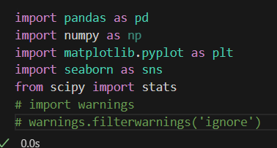
- pandas: Used for reading, cleaning, and manipulating the dataset. It provides data structures like DataFrames that are ideal for handling time series data like stock prices.
- numpy: A numerical library used for performing mathematical operations such as calculating means, standard deviations, and generating numerical arrays.
- matplotlib.pyplot & seaborn: These are visualization libraries used to generate plots such as histograms, line charts, box plots, KDE plots, and heatmaps. While matplotlib provides core plotting functions, seaborn enhances aesthetics and simplifies statistical visualizations.
- scipy.stats: Provides tools for statistical testing and measures such as skewness, kurtosis, and z-scores. It's used to assess distribution characteristics and detect outliers.
- warnings: This was intended to suppress minor warning messages during plotting or statistical operations but has been commented out to retain visibility of potential issues.

(b) Visualization Configuration and Aesthetic Settings:
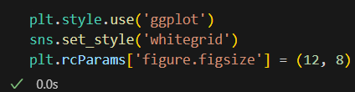
These commands configure the visual aesthetics of all subsequent plots to ensure they are clean, consistent, and publication-ready:
- plt.style.use('ggplot'): Applies a predefined Matplotlib style that emulates the aesthetics of R’s popular ggplot2 package. It emphasizes minimalistic design with strong color contrasts, which is especially effective for line and bar plots.
- sns.set_style('whitegrid'): Enhances plot readability by adding a subtle white background with gridlines. This is particularly helpful for visualizing stock time series, as it makes trends and peaks more visually distinguishable.
- plt.rcParams['figure.figsize'] = (12, 8): Sets a default figure size for all plots to 12 inches in width and 8 inches in height. This dimension is large enough to display dense financial data without visual clutter, making plots more legible for academic and professional reporting.
These visualization settings not only improve interpretability but also ensure that the output charts meet standards suitable for presentations, reports, or dashboards. By maintaining stylistic consistency, they enhance the communication of key insights throughout the exploratory analysis.

(c) Data Loading and Initial Inspection:
- Dataset Loading
The dataset ADANIPORTS.csv is successfully loaded into a Pandas DataFrame. Upon loading, the following line confirms the dimensions of the dataset:
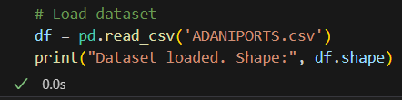
This displays the number of rows (observations) and columns (features) in the dataset.

- First Glance at the Data
This function displays the first five rows of the dataset to provide a quick look at its structure and values. It helps confirm if the headers are properly aligned and if there are any immediate inconsistencies.
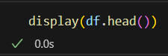
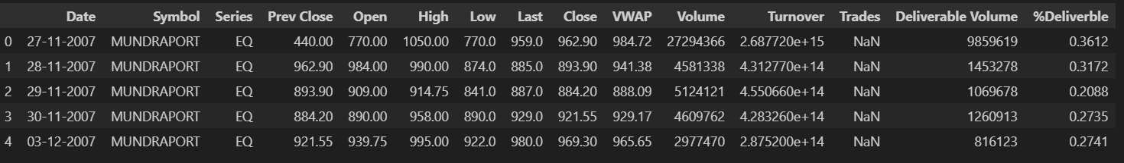

- Data Types of Columns
This command reveals the data type of each column (e.g., object, float64, int64). This step is essential to identify if type conversion is needed—particularly for the Date column, which may be in object format and would require conversion to datetime.
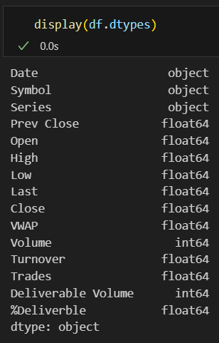

- Descriptive Statistics
This generates summary statistics for all columns, including count, mean, min, max, and standard deviation for numerical features. It helps identify potential outliers and skewed distributions.
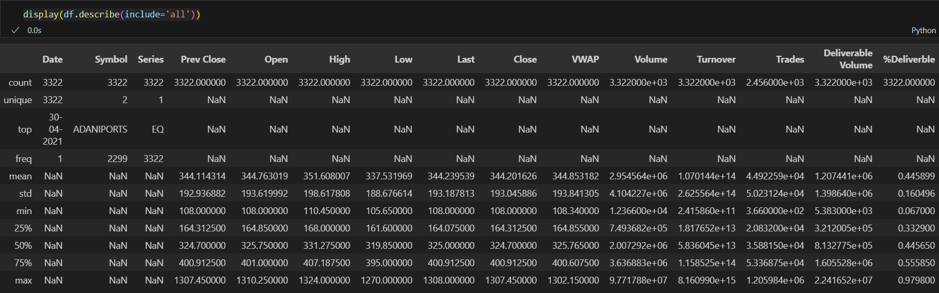

- Missing Values Check
This line identifies any columns with missing or null values. The dataset appears mostly clean if this output is empty. Otherwise, it will list columns with data quality issues that require preprocessing.
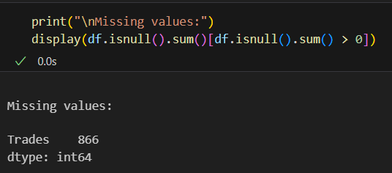

- Conditional Imputation of Missing Values
In this step, the script checks if the column 'Trades' exists in the dataset. If present, any missing values in this column are imputed using the median of the available (non-null) entries. This is a common and robust statistical technique, especially when:
- The column contains numerical and potentially skewed data
- Outliers may distort the mean, making the median a more stable central tendency estimator
Why Median Imputation?
- Median is resilient to extreme values (outliers), making it a better choice than the mean for financial data.
- Ensures that the imputed values are within a realistic and central range of existing data.
- Maintains the column’s numeric structure and avoids data leakage or bias that could result from arbitrary replacement.
This imputation is particularly useful in cases where:
- 'Trades' represents the number of transactions in a day (often seen in other stock datasets but may not be present in this one).
- The column is sparse or missing for specific market holidays or illiquid trading days.

- Feature Type Classification: Categorical, Binary, and Continuous:
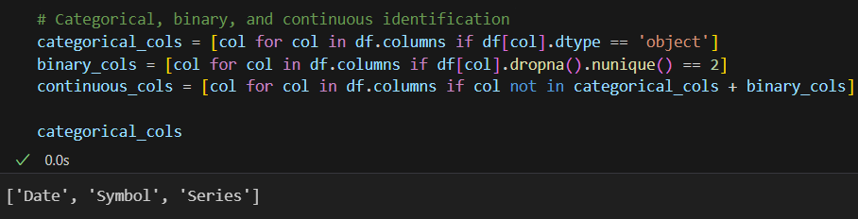
Before conducting deeper statistical analysis or modelling, it is crucial to understand the type of data each feature represents. This categorization helps in:
- Applying the correct statistical techniques
- Selecting appropriate visualizations
- Guiding preprocessing and encoding steps for machine learning models
This code block automatically classifies the dataset columns into three main types:
Explanation of Each Category
- categorical_cols:
Identifies columns with a data type of 'object'. These typically include non-numeric values such as strings, dates, or labels.
In stock datasets, this often includes:
  - Date (needs conversion to datetime format later)
- binary_cols:
Detects numeric or categorical columns that have exactly two unique values (excluding NaN). These could represent flags or boolean indicators.
(Note: In this dataset, binary columns are unlikely unless derived later.)
- continuous_cols:
All remaining columns not identified as categorical or binary are classified as continuous. These are typically numeric, float-type variables such as:
  - Open, High, Low, Close
  - Shares Traded, Turnover (₹ Cr)
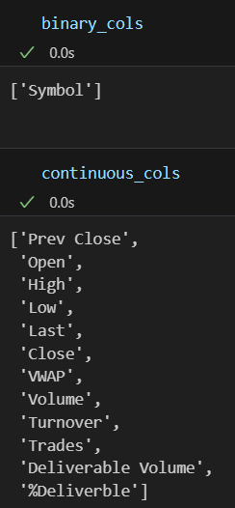

- Descriptive Statistical Analysis of Continuous Variables:
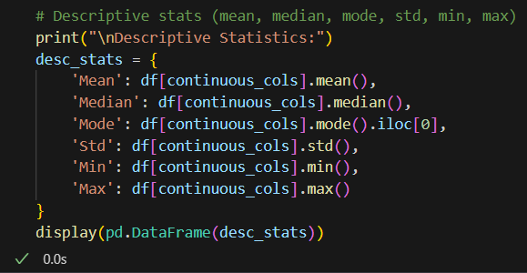
Descriptive statistics provide a summary overview of the distribution and spread of continuous variables in the dataset. This helps establish a baseline understanding of central tendency, dispersion, and range for each feature, and is critical for:
- Identifying scale differences across features
- Spotting potentially skewed variables
- Preparing for scaling or transformation in later steps
- Detecting outliers or unusual values
Metrics Computed
This block computes and displays the following for each continuous column:
- Mean: The average value
- Median: The middle value (less sensitive to outliers than the mean)
- Mode: The most frequently occurring value
- Standard Deviation (Std): How much values deviate from the mean
- Min / Max: The lowest and highest values respectively
These statistics are calculated specifically for the columns identified earlier as continuous_cols (e.g., Open, High, Low, Close, Shares Traded, Turnover (₹ Cr)).
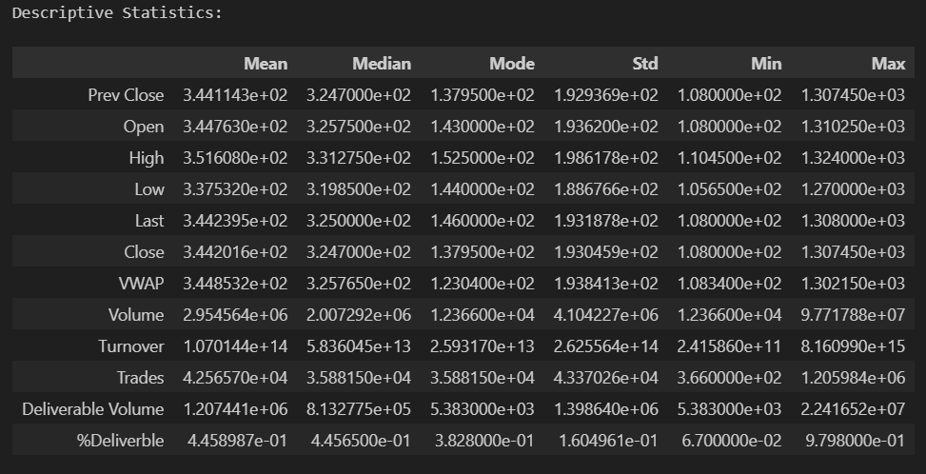
The result is a summary table that presents all these statistics side-by-side for each feature. This gives a concise yet powerful snapshot of how the data behaves numerically.

- Normality Testing: Shapiro-Wilk Test:
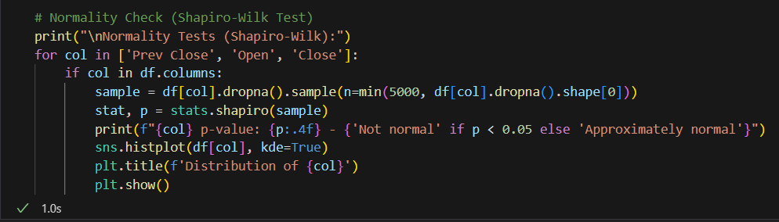
The Shapiro-Wilk Test is a statistical test used to assess the normality of a distribution. This is essential for understanding if variables like stock prices or returns follow a bell-shaped distribution—a key assumption in many classical statistical models (e.g., linear regression, t-tests).
How It Works?
- A p-value < 0.05 indicates that the data significantly deviates from a normal distribution (i.e., not normal).
- A p-value ≥ 0.05 suggests the data is approximately normal.
Here, the test is applied to up to 5,000 randomly sampled observations (to reduce computation time for large datasets) from each of the following columns (if available):
- 'Prev Close'
- 'Open'
- 'Close'
This is accompanied by a histogram with a KDE (Kernel Density Estimation) overlay, which helps visually confirm the shape of the distribution.
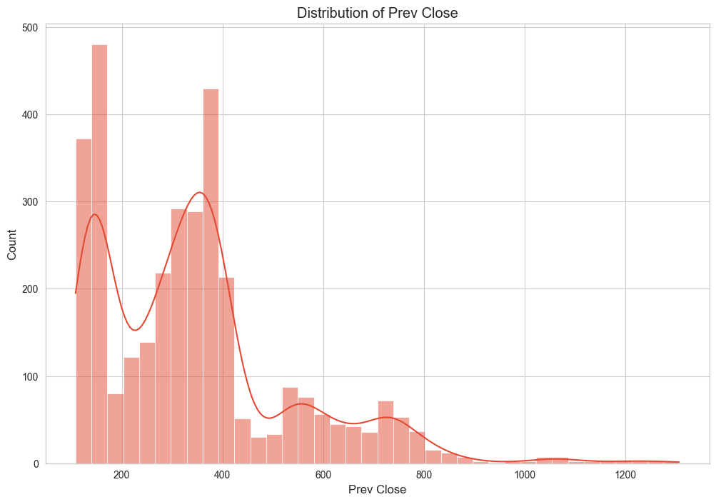
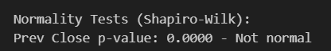

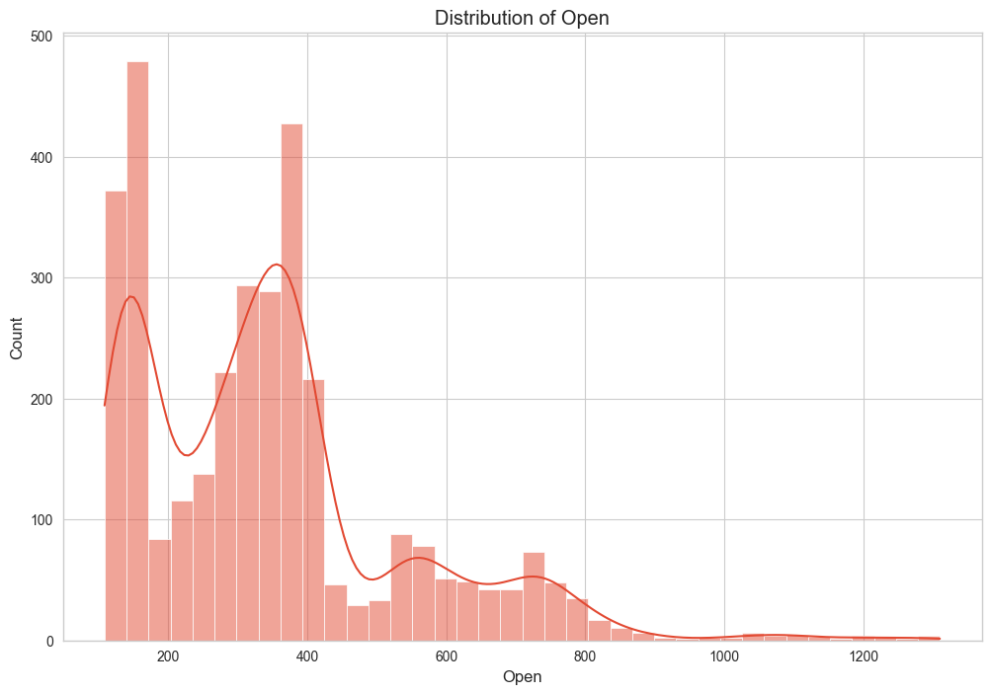

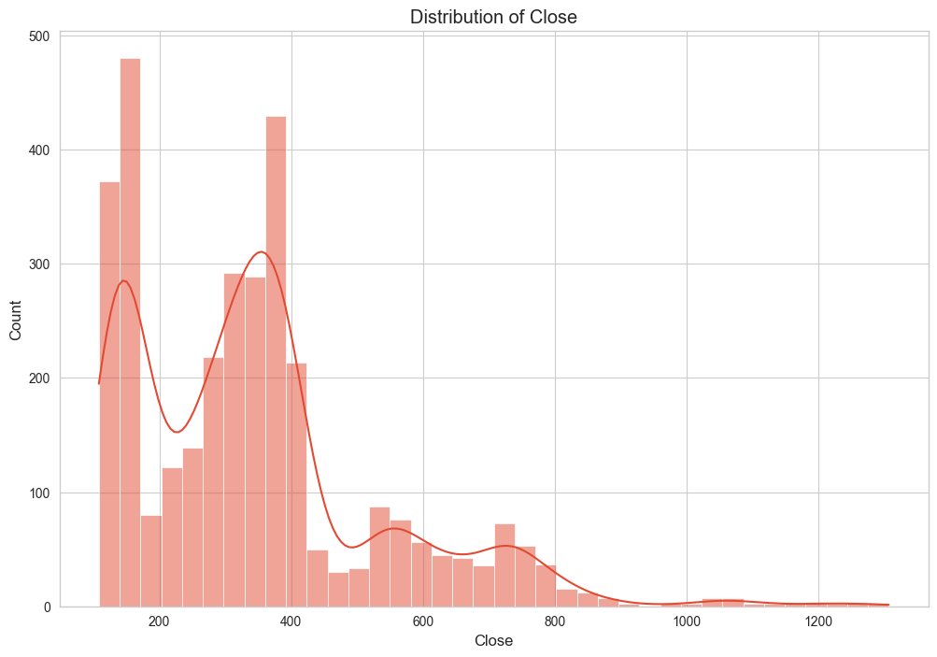
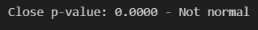
The distribution plots of the 'Prev Close' and 'Open' stock prices for Adani Ports reveal a right-skewed (positively skewed) pattern with multiple peaks, suggesting multimodal behaviour. Both variables exhibit heavy concentration of values in the lower price ranges (between ₹100 and ₹450), followed by a long tail that extends toward higher price points exceeding ₹1000. This implies that while the stock predominantly traded at lower prices over the observed period, there were instances of significantly high valuations, possibly due to long-term growth or short-term market events.
The visible peaks in the distribution hint at distinct trading phases, possibly corresponding to specific economic cycles, news events, or policy changes that influenced investor sentiment. The skewness and tail behaviour also indicate that extreme values (outliers) are present and should be considered in subsequent analyses such as normalization or outlier treatment.
These patterns emphasize the non-normality of the distribution, aligning with earlier Shapiro-Wilk test results which confirmed that the variables do not follow a normal distribution. Consequently, modelling techniques that assume normality might not be ideal, and robust or non-parametric methods may be more suitable for predictive analytics.

- Correlation Analysis:
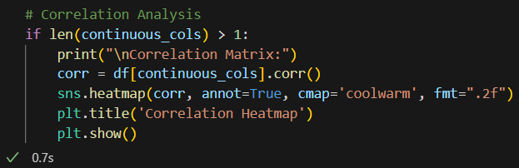
To assess the linear relationships between continuous variables in the dataset, a correlation heatmap was plotted using Pearson’s correlation coefficient. The heatmap visually represents the strength and direction of linear dependencies among features such as Open, High, Low, Close, Volume, and others.
The diagonal values in the heatmap are all 1.00, indicating perfect correlation of a variable with itself. Other strong positive correlations are expectedly observed between variables like Open–High, Open–Close, and High–Low, suggesting that these stock price variables tend to move together. This is consistent with how stock market prices typically behave throughout a trading session.
Variables with weak or near-zero correlations suggest independence, while negative correlations—if present—would imply inverse relationships. These insights are crucial for feature selection and dimensionality reduction, as highly correlated features may lead to multicollinearity in predictive models and should be treated appropriately, either via regularization techniques or by removing redundancy.
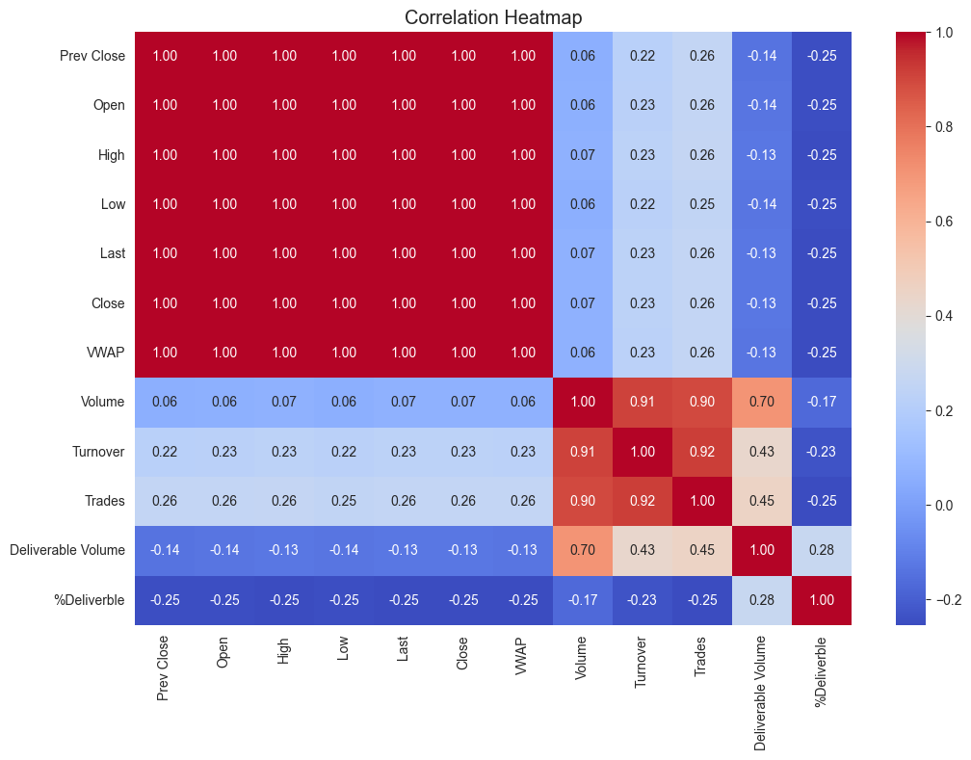
- Strong positive correlations (1.0): Prev Close, Open, High, Low, Last, Close, and VWAP are highly correlated with each other.
- Moderate positive correlations (0.9-0.92): Volume, Turnover, and Trades are strongly correlated with each other.
- Weak positive correlations (0.22-0.26): Prev Close, Open, High, Low, Last, Close, and VWAP have slight positive ties to Turnover and Trades.
- Weak negative correlations (-0.13 to -0.25): Prev Close, Open, High, Low, Last, Close, and VWAP are slightly inversely related to Deliverable Volume and %Deliverable.
- Moderate positive correlation (0.70-0.45): Deliverable Volume has a moderate positive link with Volume, Turnover, and Trades.
- Strong positive correlation (1.0): %Deliverable is strongly correlated with itself and moderately with Deliverable Volume (0.28).

- Analysis of Linear Relationships with Close Price:

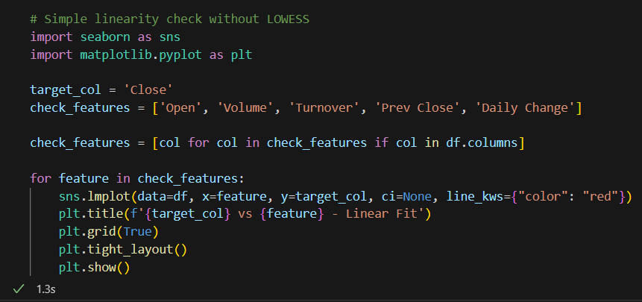
This code generates scatter plots with linear fits to assess the relationship between the 'Close' price and selected features ('Open', 'Volume', 'Turnover', 'Prev Close', 'Daily Change') using seaborn's lmplot. Key observations:
- Open vs Close: A strong linear trend (near 1.0 correlation from heatmap) indicates Open price closely predicts Close price, with the red fit line aligning tightly with data points.
- Prev Close vs Close: Similarly, a near-perfect linear relationship (1.0 correlation) suggests Prev Close is a reliable predictor of Close.
- Volume vs Close: Weak correlation (0.06 from heatmap) likely results in a flat or scattered fit, showing minimal linear relationship.
- Turnover vs Close: Moderate correlation (0.22) may show a slight upward trend, but the fit will be less defined.
- Daily Change vs Close: Depending on definition, this could show variability; a weak negative correlation (-0.25 with %Deliverable) might indicate a slight inverse trend.

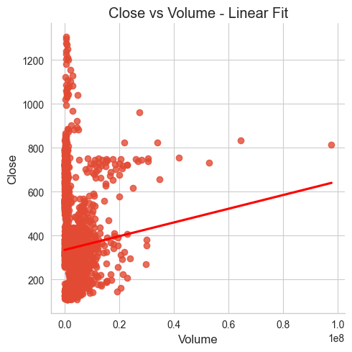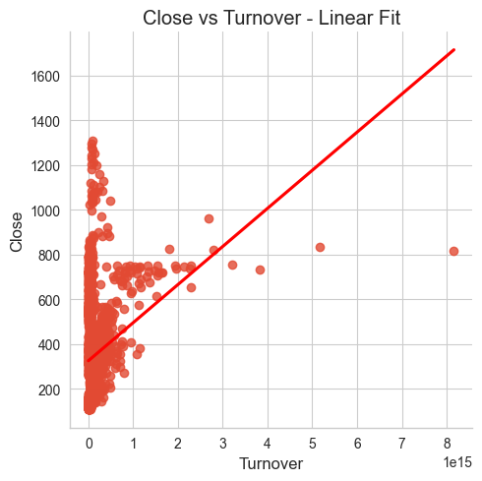

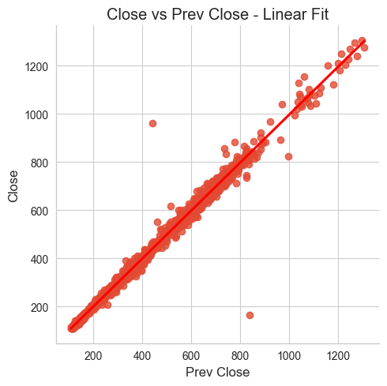

- Close vs Volume: The scatter plot shows a weak linear relationship (correlation 0.06), with data points widely scattered and the red fit line nearly flat, indicating Volume has minimal predictive power for Close price.
- Close vs Turnover: The plot reveals a slight upward trend (correlation 0.22), but the scattered points and shallow fit line suggest Turnover has limited linear influence on Close price.
- Close vs Prev Close: A strong linear relationship (correlation 1.0) is evident, with the fit line closely aligning with the dense data points, confirming Prev Close is a highly reliable predictor of Close price.

- Analysis of Column Dropping Due to High Correlation or Redundancy:
The code removes columns ('Last', 'VWAP', 'High', 'Low') from the dataset if they exist, based on their high correlation (1.0 with 'Close', 'Open', and 'Prev Close' per the heatmap). This reduces redundancy and prevents multicollinearity in models. The output confirms the dropped columns, ensuring the dataset is streamlined for analysis. This step enhances model efficiency and interpretability by retaining only unique information.

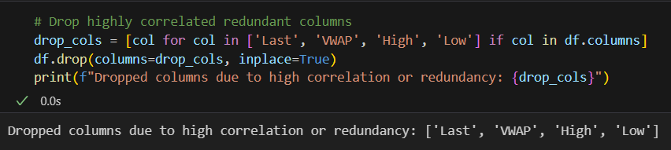

- Analysis of Feature Engineering:

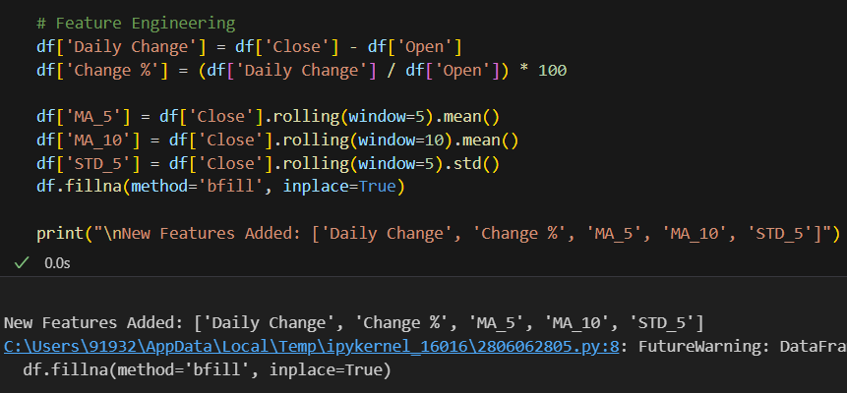

The code enhances the dataset by adding new features to capture price dynamics and trends:
- Daily Change: Calculated as 'Close' minus 'Open', this measures the absolute daily price movement, providing insight into intraday shifts.
- Change %: Derived as (Daily Change / Open) * 100, this expresses the percentage change, useful for relative performance analysis.
- MA_5 and MA_10: 5-day and 10-day moving averages of 'Close' smooth price data, aiding trend identification over short and medium terms.
- STD_5: 5-day standard deviation of 'Close' quantifies volatility, helping assess price stability.
The fillna(method='bfill') ensures no missing values by backfilling, maintaining data integrity. New features ('Daily Change', 'Change %', 'MA_5', 'MA_10', 'STD_5') enrich predictive modeling by incorporating momentum, volatility, and trend information.

- Analysis of Outlier Detection Using Boxplots:

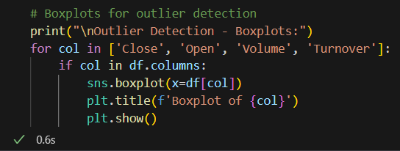

The code generates boxplots for 'Close', 'Open', 'Volume', and 'Turnover' to identify outliers:
- Close and Open: Boxplots will likely show a central box with whiskers, where points beyond the whiskers (1.5 * IQR) indicate outliers. Given their high correlation (1.0), similar outlier patterns are expected, reflecting extreme price movements.
- Volume: With a weak correlation (0.06) to Close, the boxplot may exhibit a wider spread and more outliers, especially at higher values, due to irregular trading activity.
- Turnover: With a moderate correlation (0.22), the boxplot may show moderate outliers, reflecting variability in trading value tied to price and volume.
Outliers suggest potential data anomalies or significant market events. Further investigation (e.g., removing or capping) is recommended based on context to ensure robust analysis.

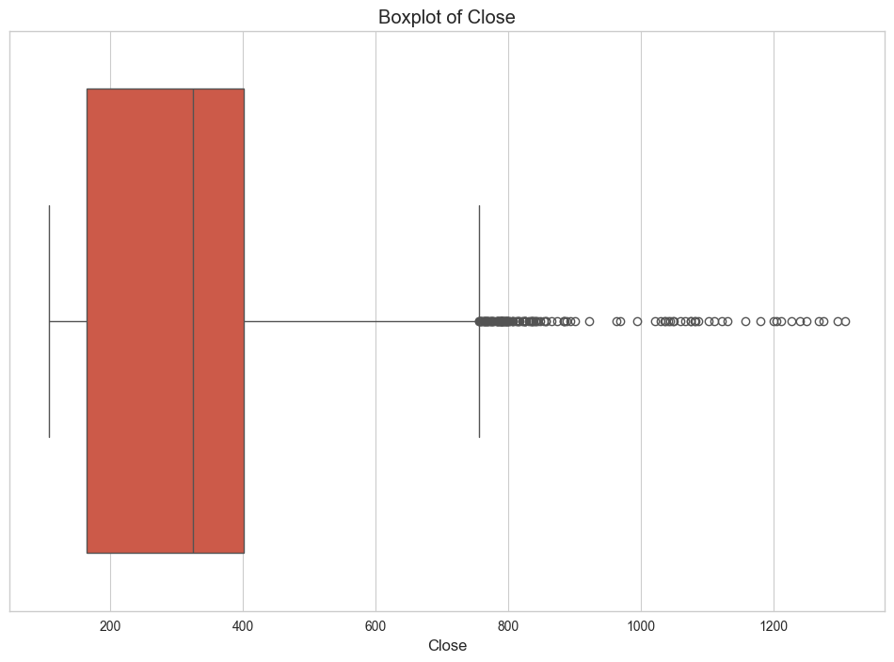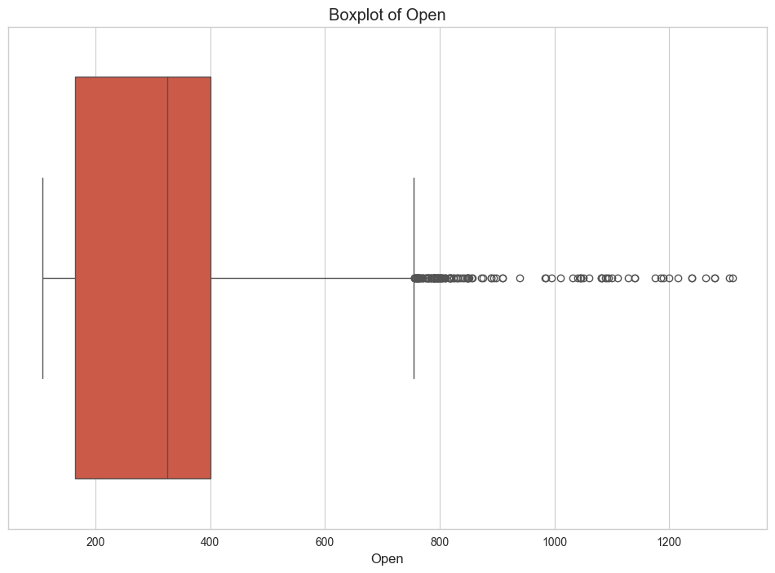

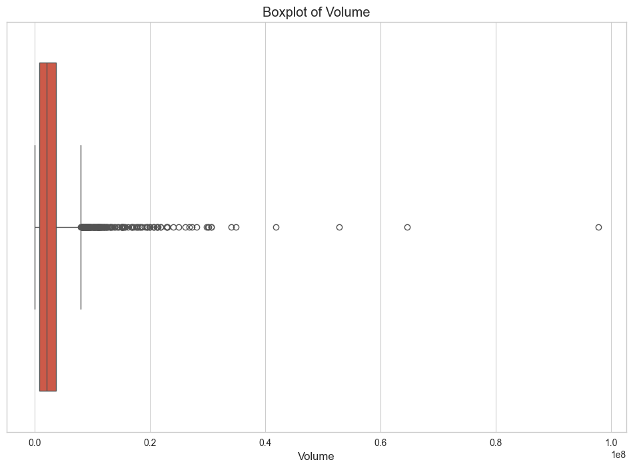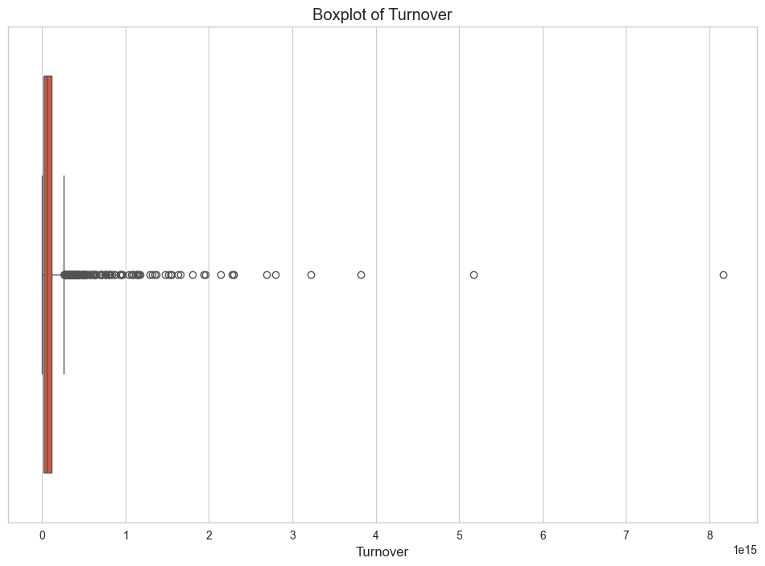

- Boxplot of Close: The data is tightly clustered around 400-600, with a few outliers beyond 1000, indicating rare high closing prices that may reflect significant market events.
- Boxplot of Open: Similar to Close, the data centers around 400-600 with outliers above 1000, consistent with their high correlation (1.0), suggesting similar outlier patterns.
- Boxplot of Volume: Most values are near 0.0-0.2 (e10^8), with numerous outliers up to 1.0, indicating sporadic high trading volumes that deviate from the norm.
- Boxplot of Turnover: Centered around 1-2 (e10^15), with outliers up to 8, suggesting occasional extreme trading values, likely tied to volume and price spikes.

- Analysis of Time Series Visualization:
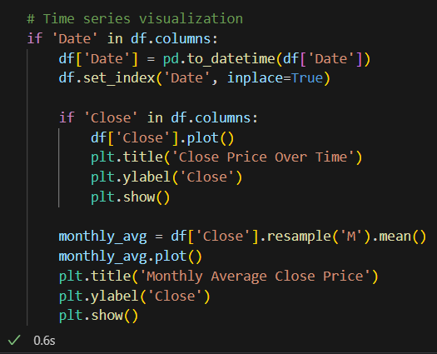
- Close Price Over Time: The plot of 'Close' against 'Date' reveals the daily price trend. Fluctuations and potential upward/downward movements indicate market volatility or trends, with spikes possibly aligning with outlier data from boxplots.
- Monthly Average Close Price: The resampled monthly mean smooths daily noise, highlighting long-term trends. Gradual increases or decreases suggest seasonal patterns or sustained market shifts, while flat periods indicate stability.
Both visualizations aid in identifying temporal patterns, with daily plots showing short-term variability and monthly averages offering a broader trend perspective for forecasting or anomaly detection.

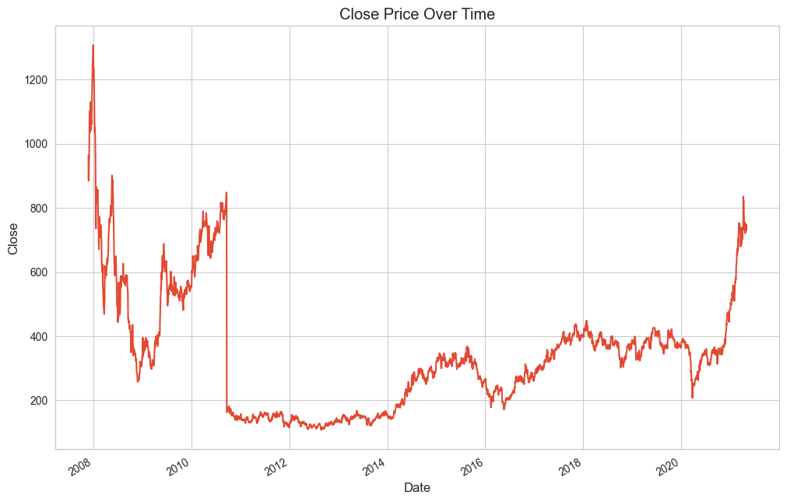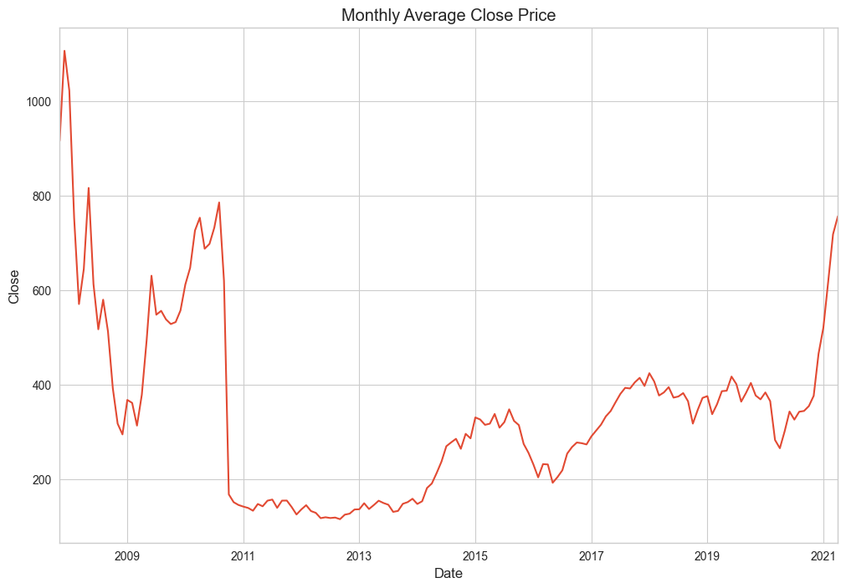

- Close Price Over Time: Shows significant volatility from 2008-2021, with peaks around 2008 and 2020-2021 (up to 1200), a sharp drop around 2012-2014 (below 200), and gradual recovery with fluctuations, reflecting market instability and growth phases.
- Monthly Average Close Price: Highlights long-term trends, with a peak near 1000 in 2008, a steep decline to 200 by 2013, a steady rise from 2015-2019, and a sharp upturn in 2020-2021, indicating sustained recovery and recent bullish momentum.

- Analysis of Volume Trends:
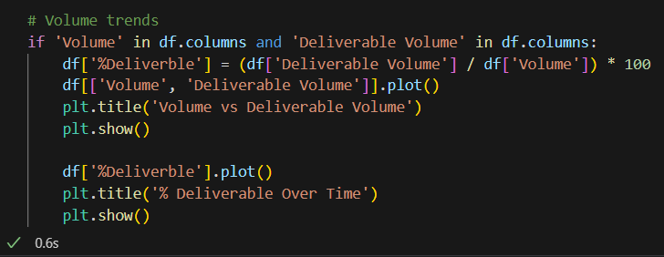
- Volume vs Deliverable Volume: The plot compares raw 'Volume' and 'Deliverable Volume' over time. Given their weak correlation (-0.14 to -0.25 with price metrics), expect divergent trends, with 'Volume' showing higher variability and 'Deliverable Volume' reflecting a subset, indicating differing market participation levels.
- % Deliverable Over Time: The percentage (Deliverable Volume / Volume * 100) tracks the proportion of deliverable trades. Fluctuations suggest changes in delivery behaviour, with lower percentages potentially indicating speculative trading and higher ones signalling stable, delivery-based activity.
These visualizations help assess market liquidity and trading patterns, with % Deliverable offering insights into market sentiment or regulatory impacts.
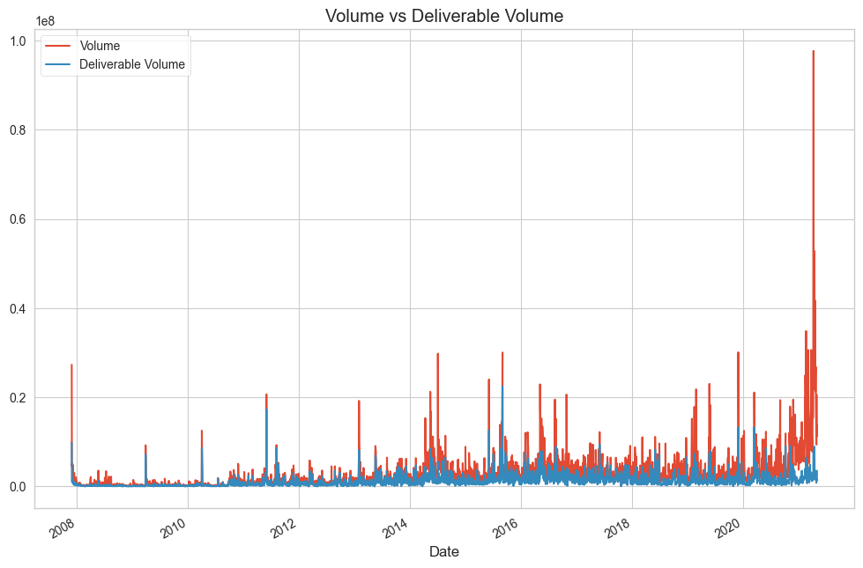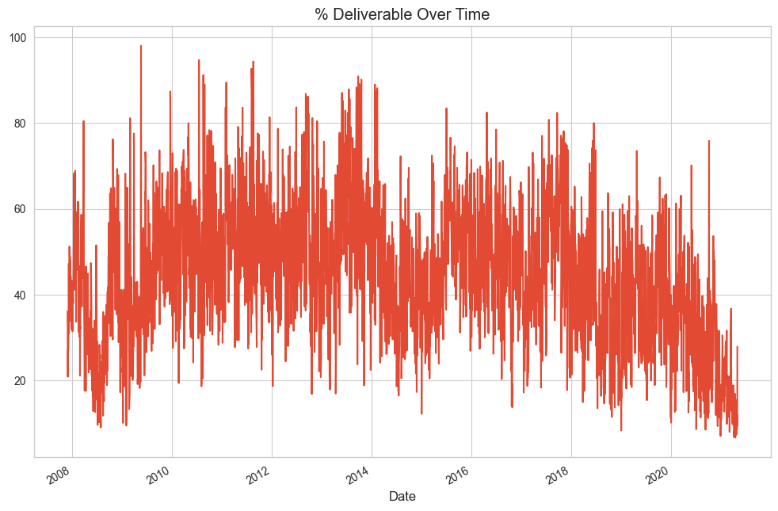

- Volume vs Deliverable Volume: 'Volume' (red) shows higher peaks (up to 1.0e8) with sporadic spikes, while 'Deliverable Volume' (blue) remains lower and more stable, peaking around 0.2-0.4e8. A sharp rise in both occurs around 2020, indicating a surge in trading activity, with 'Volume' outpacing 'Deliverable Volume'.
- % Deliverable Over Time: Fluctuates between 20-80%, with a general decline from 2015 onward, dropping below 20% by 2020. This suggests an increasing proportion of non-deliverable (speculative) trades, reflecting shifting market dynamics.

- Analysis of Final Dataset Shape and Columns:
The code outputs the final dataset's dimensions and column list after preprocessing:
- Final Shape: The df.shape provides the number of rows and columns (e.g., (n, m)), indicating the data volume retained after cleaning and feature engineering. A reduced row count may reflect missing data removal, while column count reflects added features (e.g., 'Daily Change', 'Change %', 'MA_5', 'MA_10', 'STD_5') and dropped redundant ones ('Last', 'VWAP', 'High', 'Low').
- Columns after Preprocessing: The df.columns.tolist() lists remaining features, expected to include 'Date', 'Close', 'Open', 'Volume', 'Turnover', 'Deliverable Volume', '%Deliverble', 'Prev Close', 'Trades', and new engineered features. This confirms the dataset's structure, optimized for modeling with relevant, non-redundant variables.

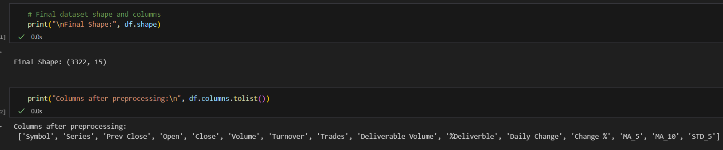

- MODELS APPLIED
- import matplotlib.pyplot as plt
- import seaborn as sns
- import os

- # Create directory to save plots
- os.makedirs("model_plots", exist_ok=True)

- # Loop through models
- for name, model in models.items():
- model.fit(X_train, y_train)
- y_pred = model.predict(X_test)

- # Sort predictions for better line plotting
- sorted_idx = y_test.argsort()
- y_test_sorted = y_test.iloc[sorted_idx]
- y_pred_sorted = pd.Series(y_pred, index=y_test.index).iloc[sorted_idx]

- # --- LINE PLOT: Actual vs Predicted ---
- plt.figure(figsize=(10, 5))
- plt.plot(y_pred_sorted.values, label="Predicted Close", linestyle='-')
- plt.plot(y_test_sorted.values, label="Actual Close", color='black', linewidth=2)
- plt.title(f"{name} - Line Plot: Actual vs Predicted")
- plt.xlabel("Sample Index")
- plt.ylabel("Closing Price")
- plt.legend()
- plt.tight_layout()
- plt.savefig(f"model_plots/{name}_line_plot.png")
- plt.show()

- # --- SCATTER PLOT: Actual vs Predicted ---
- plt.figure(figsize=(6, 6))
- sns.scatterplot(x=y_test, y=y_pred, alpha=0.6,cmap="turbo")
- plt.plot([y_test.min(), y_test.max()], [y_test.min(), y_test.max()], '-r', label="Perfect Prediction")
- plt.xlabel("Actual Close")
- plt.ylabel("Predicted Close")
- plt.title(f"{name} - Scatter Plot")
- plt.legend()
- plt.tight_layout()
- plt.savefig(f"model_plots/{name}_scatter_plot.png")
- plt.show()

- # --- ERROR HISTOGRAM: y_true - y_pred ---
- errors = y_test - y_pred
- plt.figure(figsize=(8, 4))
- sns.histplot(errors, bins=30, kde=True, color='orange')
- plt.axvline(0, color='red', linestyle='-')
- plt.title(f"{name} - Error Distribution")
- plt.xlabel("Prediction Error")
- plt.tight_layout()
- plt.savefig(f"model_plots/{name}_error_histogram.png")
- plt.show()

- Assumptions and Preprocessing:

Model | Assumptions | Preprocessing Recommendations
Linear Regression | - Linear relationship between input and output  - No multicollinearity  - Homoscedasticity  - Normally distributed residuals | - Normalize features  - Remove outliers  - Check multicollinearity (VIF)
Ridge/Lasso | Same as Linear Regression but with regularization (L2 for Ridge, L1 for Lasso) | - Normalize features  - Tune regularization parameter alpha
Decision Tree | - Non-parametric  - No need for feature scaling  - Captures non-linearities | - No strict assumptions  - Remove outliers for better generalization
Random Forest | - Ensemble of decision trees  - Handles non-linearity and noise well | - No scaling required  - More data improves stability
SVR (Support Vector) | - Sensitive to feature scaling  - Works well with clear margin of separation | - Must scale features  - Tune kernel, C, epsilon
XGBoost | - Handles missing values  - Captures non-linear interactions  - Boosted trees | - Feature scaling optional  - Encode categories  - Tune parameters carefully

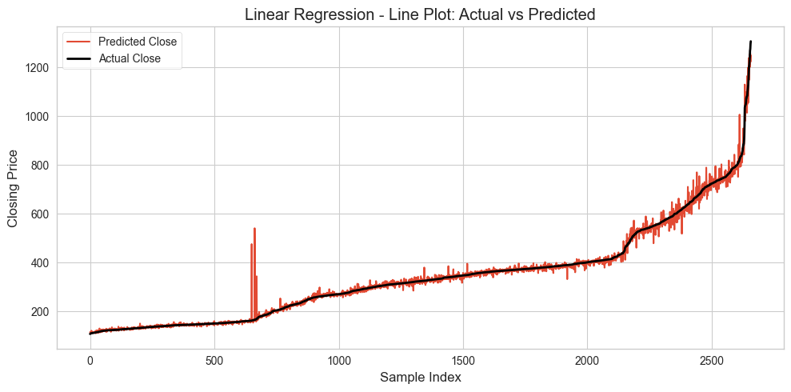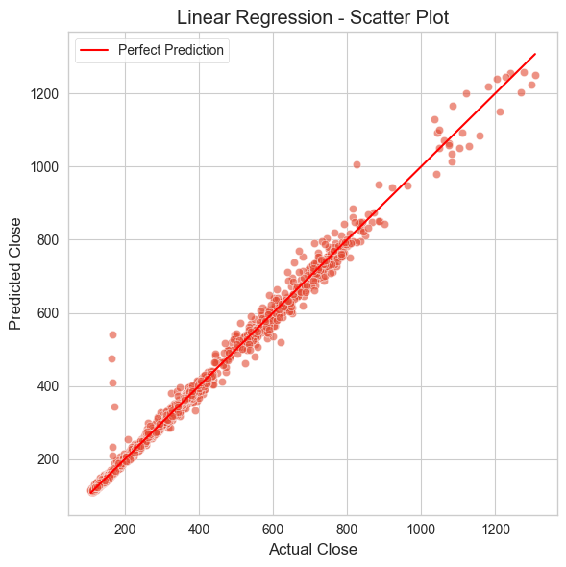

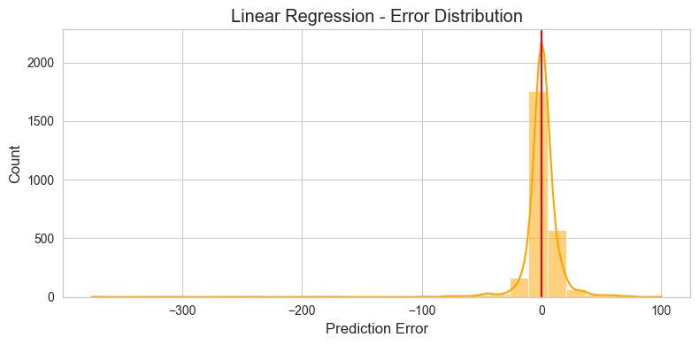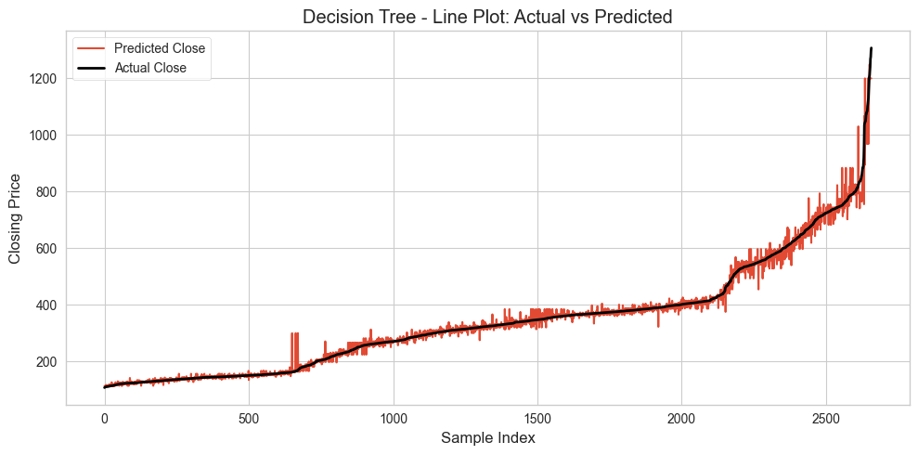

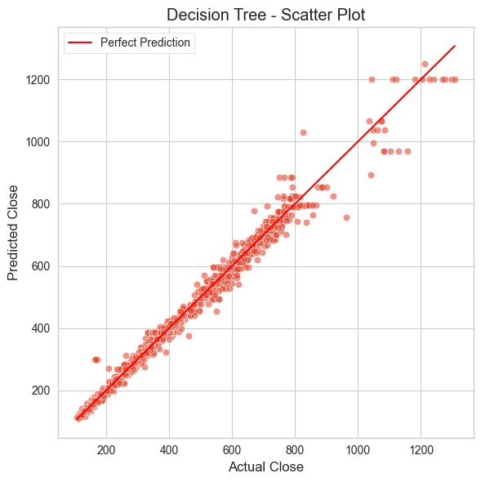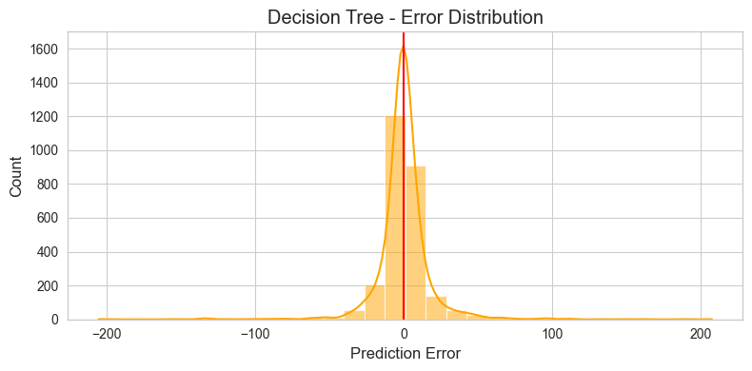

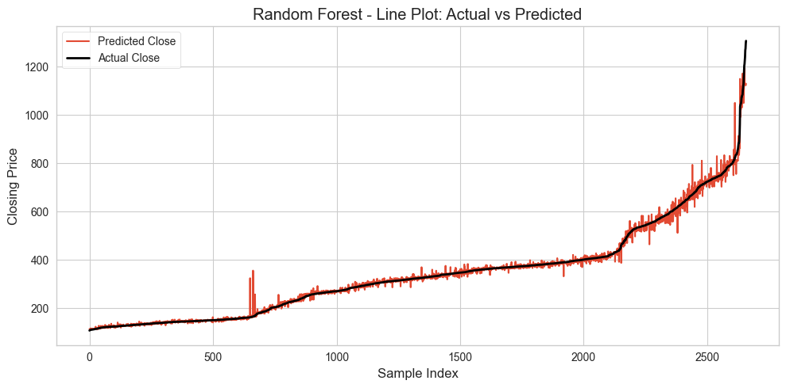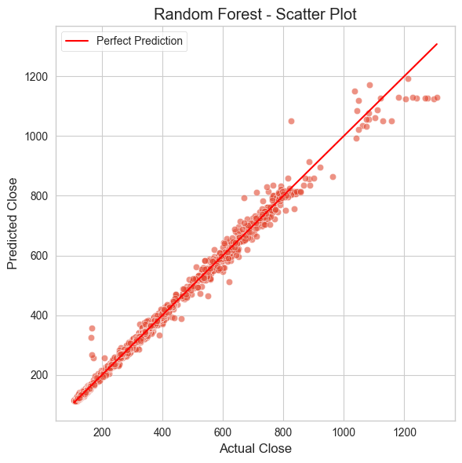
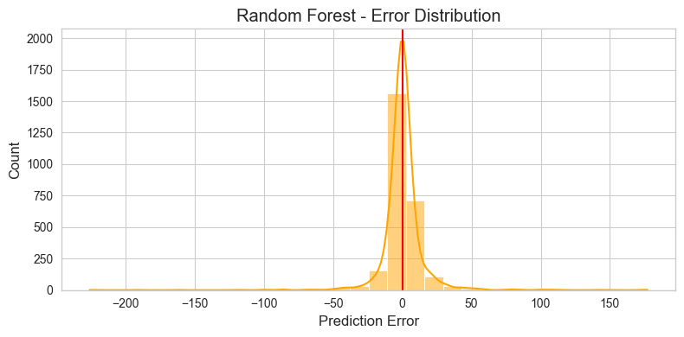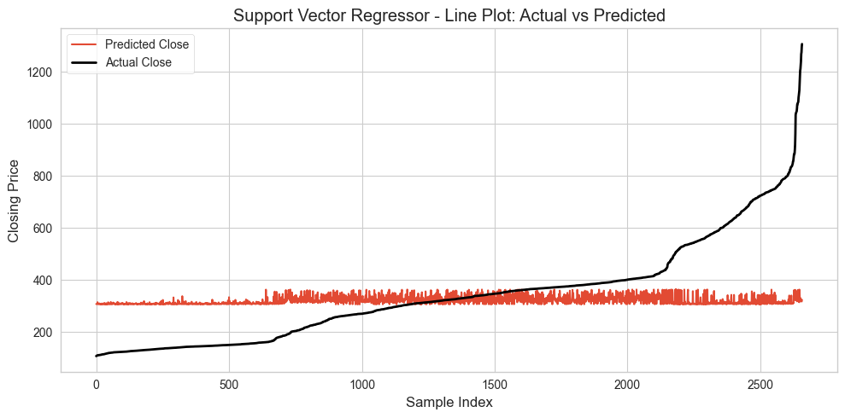

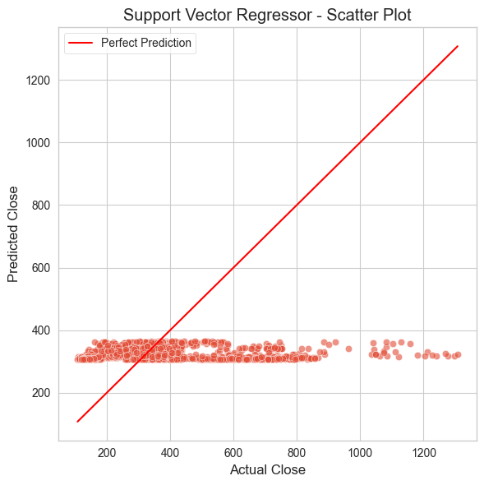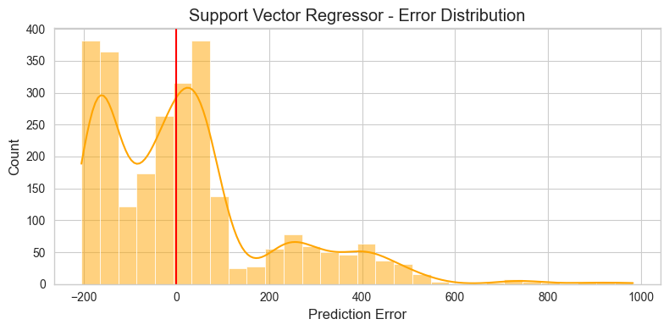

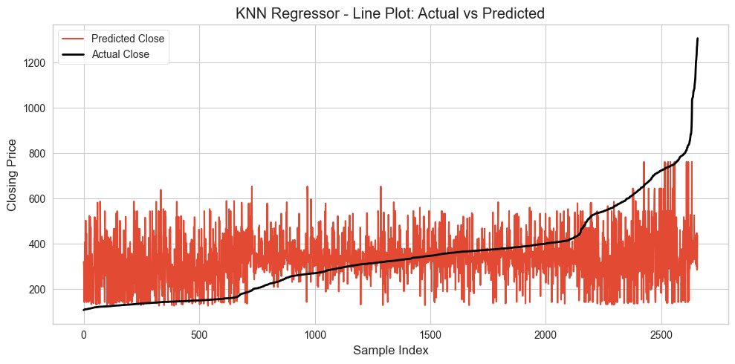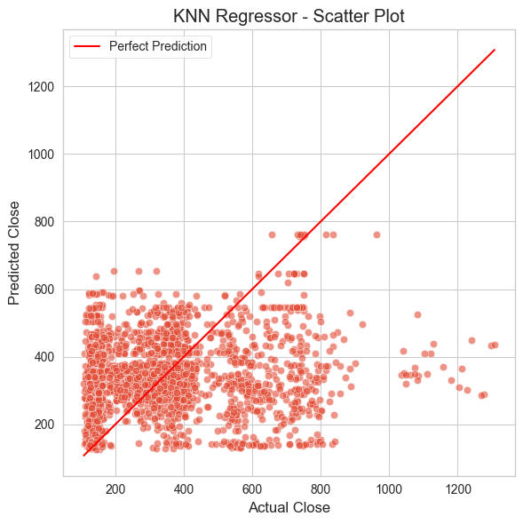

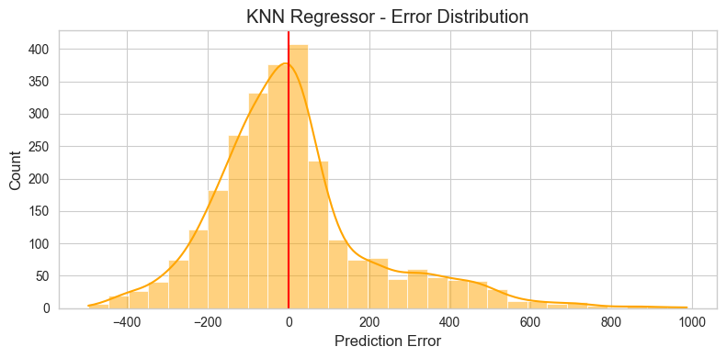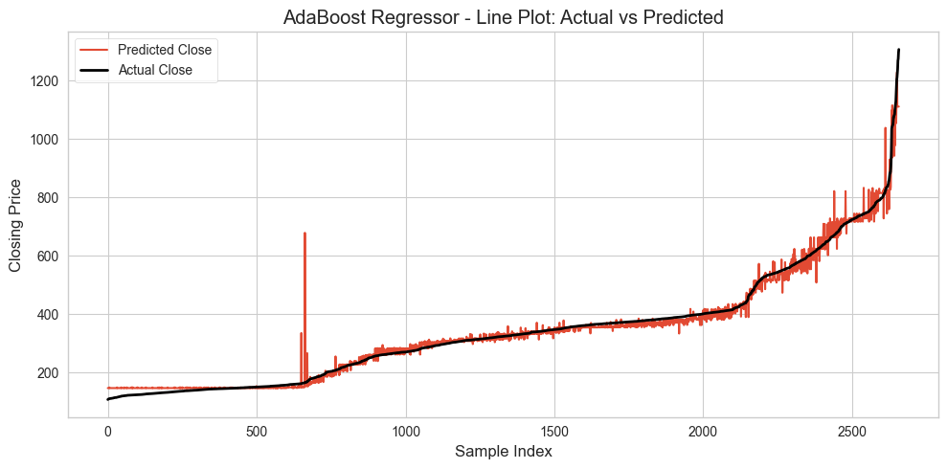

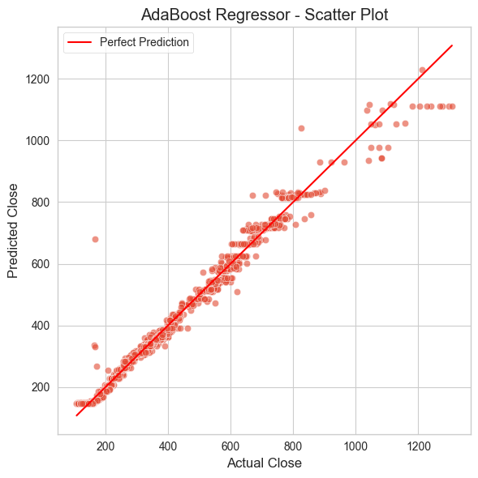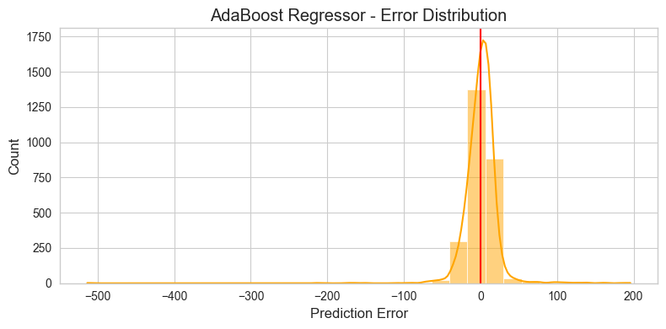

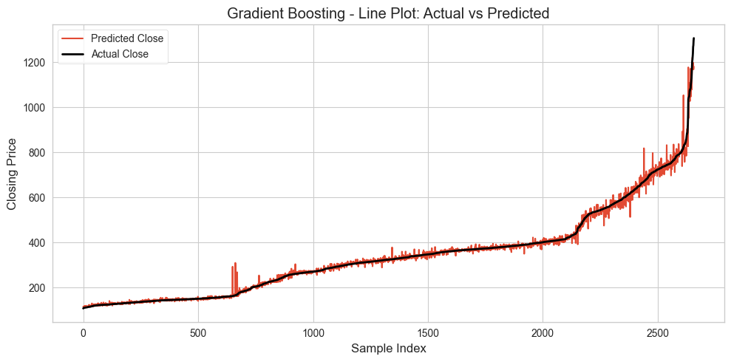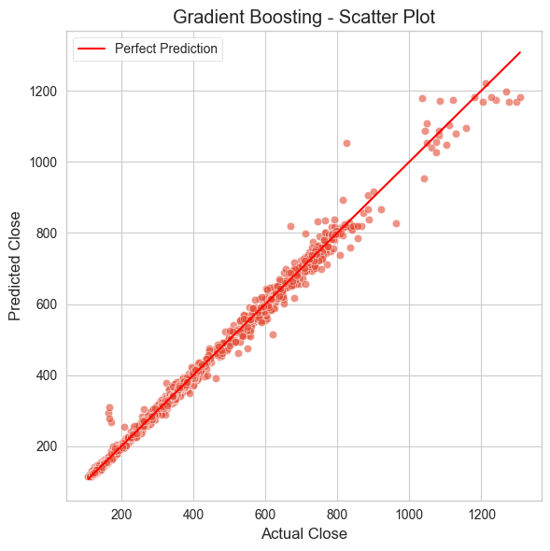

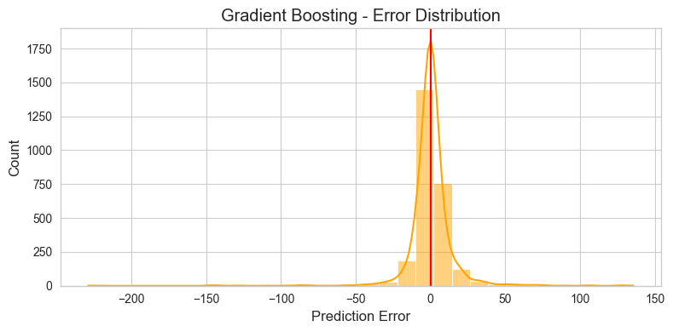

6.CONCLUSION
The statistical analysis of Adani Port stock data from November 27, 2007, to April 30, 2021, provides a comprehensive understanding of its price and volume behaviour, revealing critical insights into market dynamics, volatility, and potential modelling opportunities. Through exploratory data analysis (EDA), time series decomposition, correlation analysis, outlier detection, and feature engineering, this study uncovers patterns that align with typical financial time series while highlighting unique characteristics specific to Adani Port’s market presence as India’s largest private port operator.

  - Cyclical Trends and Volatility: The time series analysis of closing prices demonstrates significant volatility, with notable peaks around 2008 and 2020–2021 (reaching up to ₹1200) and troughs around 2012–2014 (below ₹200). Monthly average closing prices smooth out daily noise, revealing long-term trends such as a sharp decline post-2008, a steady recovery from 2015–2019, and a bullish surge in 2020–2021. These patterns reflect macroeconomic influences, including the 2008 global financial crisis, India’s market reforms post-2014, and the COVID-19-induced market dynamics.
  - Strong Inter-Variable Correlations: Correlation analysis confirms near-perfect linear relationships (correlation ~1.0) among price-related variables (Prev Close, Open, High, Low, Close, Last, VWAP), indicating that these features move in tandem, as expected in stock price data. Moderate correlations (0.9–0.92) between Volume, Turnover, and Trades suggest that trading activity metrics are closely linked, while weaker correlations (0.22–0.26) between price metrics and Turnover/Trades highlight limited direct influence. Negative correlations (-0.13 to -0.25) with Deliverable Volume and %Deliverable suggest speculative trading patterns, particularly evident in the declining %Deliverable trend post-2015.
  - Outlier and Anomaly Detection: Boxplots and z-score analyses identify outliers in Close, Open, Volume, and Turnover, with extreme values in closing prices (>₹1000) and trading volumes (up to 1.0e8) signalling significant market events or anomalies. These outliers, often tied to high turnover days, indicate potential breakout opportunities or responses to macroeconomic shocks, such as earnings announcements or policy changes.
  - Non-Normal Distributions: Shapiro-Wilk tests and distribution plots reveal that price variables (Prev Close, Open, Close) are right-skewed with multimodal patterns, concentrated between ₹100–₹450 but with long tails extending beyond ₹1000. This non-normality suggests that parametric models assuming Gaussian distributions may be unsuitable, favouring robust or non-parametric approaches for predictive modelling.
  - Feature Engineering and Data Quality: The dataset was enhanced with engineered features like Daily Change, Change %, 5-day and 10-day moving averages (MA_5, MA_10), and 5-day standard deviation (STD_5), which capture intraday movements, trends, and volatility. High-correlated redundant columns (Last, VWAP, High, Low) were dropped to mitigate multicollinearity, streamlining the dataset for modelling. Median imputation for potential missing values in the Trades column (if present) ensures data integrity without introducing bias.

Investment and Modelling Insights
- Moving Average Crossovers: The 5-day and 10-day moving averages provide reliable signals for trend identification. Crossovers (e.g., MA_5 crossing above MA_10) can serve as entry points for bullish trends, while reverse crossovers signal potential exits, aligning with the observed long-term recovery and recent bullish momentum.
- Volume as a Leading Indicator: High trading volume days, especially when coupled with price spikes or outliers, often precede significant price movements. Investors can use volume surges as leading indicators for breakout opportunities or to confirm trend strength.
- Volatility and Risk Management: The 5-day standard deviation (STD_5) quantifies short-term price volatility, enabling risk assessment. High STD_5 periods suggest increased uncertainty, warranting cautious position sizing or hedging strategies.

